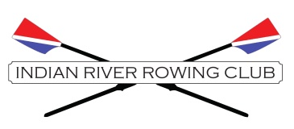
Safety Policy – Incident Reporting Form
Indian River Rowing Club strongly encourages the reporting of misconduct. Indian River Rowing Club appreciates your willingness to report in appropriate behavior.
This section is about the individual you are reporting. Please provide as much information as possible
- Name of individual you are reporting (First & Last)
Comments:

- Position(s) this individual holds or held:
Head Coach___ Assistant Coach___ Club Member___
Volunteer___ Official___ Club Employee___
Other___
This Section asks questions about the incident or incidents you are reporting. Please provide as much specific information as you are able.
- Type of Offense (i.e. what happened?)

- Where did the incident or incidents take place? (City, State, and any other location specific information)

- Please describe what happened (including…who, what, when, where)

This Section is for information about the victim or victims. If you are the victim and wish to remain anonymous, you may do so. In that case, please enter only your age, city, state, and club affiliation.
- Name(s):

- Age (or approximate age):

- Club affiliation (if any):

- Contact phone number (Note, if this person is under 18, please provide contact information for his/her parent or guardian):

- Contact Email address (Note, if this person is under 18, please provide contact information for his/her parent or guardian):

Your information: You may remain anonymous if you wish. However, providing your information is vastly helpful to a swift and effective investigation. A person reporting alleged misconduct should not fear any retribution and/or consequence when filling a report that he or she believes to be true.
- Name:
- Phone Number:
- Email Address:
- Club Affiliation (if any):
- Relationship to victim (if any):
Self___ Parent/Guardian___ Other family member___
Friend or Acquaintance___ Club member/coach or volunteer___
Other or prefer not to say___
Other information
- If you have any other information that you feel would be helpful to an investigation of the alleged offense you have reported, please do so here.

